File Management Extended Lab Practice

**Requirements:**

1. Students download this document and copy and paste their screen shots in this document. Save the document and then upload your completed document to the assignment in Canvas. Please reach out to Deb Minassian if you are unsure about these instructions.
2. Students should be using either Virtual Box or VM Ware and a distribution of Linux other than the Ubuntu VM in the NDG curriculum. Iso files are available for download in Canvas. Students who are unable to use a VM on their personal computer should reach out to Deb Minassian.

The purpose of the extended lab is to provide students with additional practice of skills learned in course. This lab also includes a refresh of commands learned in Linux I. Skill is developed through practice.

## Part 1

You are the Linux Administrator for a fast-growing IT company. You have been tasked to create, modify and manage user accounts from the Linux server. The company has hired 12 new employees to fill 4 departments in a new division. The new division includes Software, Hardware, Engineering, and ProdDev. The server must be setup with the appropriate files, folders, users, groups and permissions to ensure proper deployment.

1. Create a directory at the root (/) of the file system for the new division. Create a name that reflects the new division. Create the Software, Hardware, Engineering, and ProdDev department directories in the new division directory. Show your screen shot here.
2. Create a group for each department. The group name should reflect the department name that the group will be assigned. Show your screen shot here.
3. Create 12 new employee user accounts, assign three users for each department. Show your screen shot here.
4. Create an administrative user for each of the departments.
   1. The user will have a Bash login shell
   2. The user will belong to the respective group for each department. This will need to be the user’s primary group.

Show your screen shot here.

1. Implement security with the following modifications:
   1. Ensure that the owner of each of the directories is the department administrator and the group ownership is the group for each department.
   2. The department administrator will have full access to their respective department directories.
   3. Ensure that only the owner of a file in the department’s directory can delete the file. The user will also have ownership of their respective department folders.
   4. Normal users in each department will have full access (Read, Write and Execute) to their respective department folders.
   5. The department folders will ONLY be accessible by users/administrators in each of the respective departments. Ensure that no one else will have permissions to the folders.
   6. Show your screen shot here.

\

1. Create a document in each of the department directories.
   1. The ownerships on this file will be the same as the directory it is located in.
   2. The document should contain only one line of text that states, “This file contains confidential information for the department.”
   3. This file can be read by any user in the department, but can only be modified by the department administrator. No one else has permissions to this file.

Show your screen shot here.

## Part 2

Moving around the file system

1. Start a terminal. What is your present working directory?
2. Change your present working directory to /usr/share/themes
3. What is your present working directory now?
4. Change your present working directory to the root of the filesystem
5. Change your present working directory to /usr/bin/

Show your screen shot here.

## Part 3

Using pwd and cd with a relative path, clear your terminal window. Change the working directory to ***YOUR*** home directory.

1. Change the working directory to the Downloads directory.
2. Go back 2 directories.
3. Where are you now?
4. Change the working directory to the Documents/ directory.   
   Show your screen shot here.

## Part 4

Download this compressed zip file: [lab4files.zip](https://cis106.com/assets/lab4files.zip) from the files located in Canvas. Decompress the zip file in **your home** directory of your Virtual Machine. Use your Browser to log into Canvas and obtain the lab4files. You will not be able to access these files if you are using the NDG VM.

1. Change your present working directory to /usr/share/. Using absolute path, list all the files inside the lab4files directory.

Show your screen shot here.

1. Change your present working directory to ~/lab4files. Long list all the files inside your current working directory with human readable file sizes.
2. Long list all the files inside lab4files with human readable file size, and sorted by file size.
3. Long list all the files inside lab4files with human readable file size, sorted by file size, without the user nor the group name, and showing their inode number.
4. list all the files inside lab4files sorted by file extension and in reverse order.

Show your screen shot here.

## Part 5

You will have to install tree and exa for Part 5. Depending on which version of Linux you are running in your VM will depend on the commands you will use to install these applications. Please provide the screen shot of your installation here.

1. Using absolute path and having /etc as your present working directory. Display a tree of the directory lab4files.
2. Change your present working directory to your Downloads directory. Display a tree of the directory lab4files with the full path prefix for each file, the file permissions, and the file size in human readable format.
3. Display a tree of the directory lab4files sorted by last modified time and showing the file owner and group.

Show your screen shot here.

1. Once you have installed exa, list all the options of the exa command.
2. Using exa, long list all the files inside lab4files
3. Long list lab4files showing the header that indicates what each column means.
4. Long list lab4files without the file owner nor group including the header and the date the file was created.
5. Show your screen shot here.

## Part 6

Use this image as a visual aid during this question  
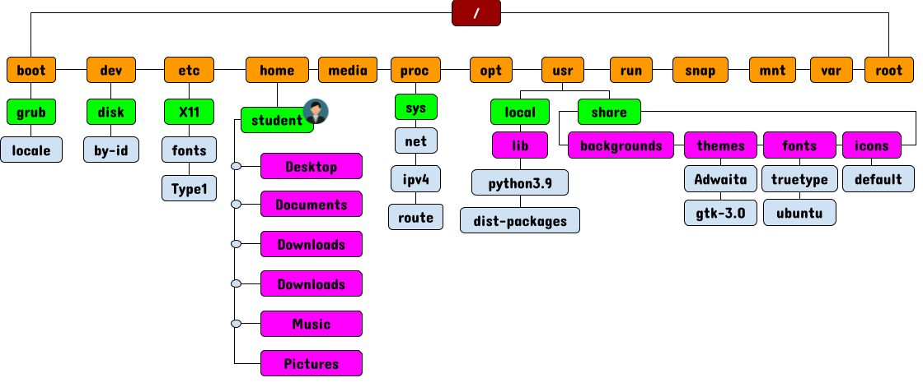

1. Open a new terminal. What is your present/current working directory?
2. Change your present/current working directory to the default directory located inside /usr
3. Change your present/current working directory to the ipv4 directory located inside /proc
4. change your present/current working directory to the previous present/working directory.
5. List all the files inside share/backgrounds without changing your present working directory.
6. List all the files inside your lab4files directory located in YOUR home directory.
7. List all the files inside your Downloads directory. Your present working directory has to be /home before your can list all the files.
8. Change your present/current working directory to disk/by-id and from there long list all the files in your home directory including hidden files.
9. List all the files sorted by modification time inside the share/themes directory.
10. List all the files sorted by file extension inside the /usr/share directory.

Show your screen shot here.

## Part 7

1. Create a Directory in **YOUR home directory** labeled: Part7.
2. Change your current working directory to ~/Part7.
3. Create 3 directories: pets,docs,songs. Inside each directory, create 2 subdirectories called: new and old.
4. Inside the new and old directories, create 3 files: file1, file2, and file3.
5. Use the tree command to list the Part7 directory.

Show your screen shot here.

## Part 8

1. Change your current working directory to: /srv/
2. Remove the file1, file2, file3 files inside the labs/pets/new/ directory without changing your current working directory.
3. Remove the pets directory without changing your current working directory.
4. Remove the docs and songs directories without changing your current working directory.
5. Remove the Part7 directory without changing your current working directory.

Show your screen shot here.

## Part 9

Download [lab5.zip](https://cis106.com/assets/lab4files.zip) from the files located in Canvas. Use your Browser to log into Canvas and obtain the file. You will not be able to access these files if you are using the NDG VM. Place the file in your HOME directory

1. Make sure that you are working on your home directory. Use the application of your choice to compression the lab5 directory. Then uncompress the files in the directory. Show your screen shot here.
2. In your home directory, create the following directories: lab5-imgs, lab5-audio, lab5-video, lab5-docs
3. Move all the files inside the lab5 directory to their respective new directories in your home directory.
4. Inside the lab5 directory, you will find a directory called Wallpaperslab5. Move this directory to your Pictures directory and rename it to NewWallpapers.
5. Rename the lab5 directory to Lab-5.

Show your screen shot here.

## Part 10

1. Go to [pexels.com](https://www.pexels.com/search/HD%20wallpaper/). Download at least 3 wallpapers. Use your Web Browser in your VM to do this task.
2. Copy the wallpapers to your Pictures/NewWallpapers directory.
3. Create a new directory in your Downloads directory (use whatever naming convention you want). Download 3 wallpapers and move them to your new directory.
4. Copy your new directory to the Pictures directory.
5. Remove the new directory in your Downloads directory.

Show your screen shot here.

## Part 11

Before working on this lab, run this command:  
curl https://cis106.com/assets/lab6.sh | bash  
This will create a directory called lab6 in your home directory. You must do this in your VM. This will not work with the NDG VM.

Show your screen shot here.

## Part 12

In your home directory, you should have a directory called lab6, if you don’t have it, make sure you complete Part 11.

1. List all the log files located in the lab6 directory.
2. Create a directory called log-files inside the lab6 directory. Move all the log files to the log-files directory.
3. List all the configuration files in the etc directory. (*Configuration files have the extension of .conf*)
4. Long list all the configuration files in the etc directory that start with letter h or letter p **sorted by file size**. Modify the ls command with the proper options so that the output looks like this: (*Notice the date*)
5. -rw-r--r-- 1 7.5K 08/19/21 /etc/pnm2ppa.conf

Show your work with a screen shot here.

## Part 13

1. List only the hidden files inside the lab6 directory.
2. List all the files with a 2 letter file extension in the lab6 directory
3. Inside the lab6 directory, list all the files that start with letter l, have one character after letter l, and the letters st. The the rest of the file name is irrelevant.
4. Inside the lab6 directory, list all the files that have an _ and two characters before the file extension.

Show your screen shot here.

## Part 14

1. List all the files that start with an uppercase letter
2. List all the files that start with an uppercase letter or a number
3. List all the files that have a number in the file name
4. List all the files that start with a lowercase letter and have a number before the file extension.

Show your screen shot here.

## Part 15

The curly braces are not a wildcard but they are equally useful. The curly braces allow you to generate arbitrary strings to use with commands.

1. **Problem 1:**  
   In the lab6 directory, create the following directory structure. Display a tree of the directory. **Take a screenshot**:

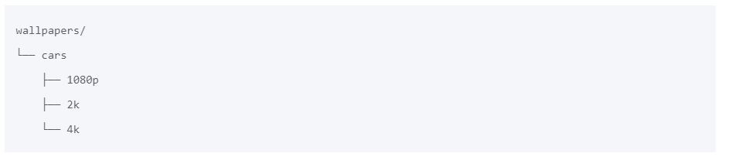

1. **Problem 2:**  
   Clear your terminal. in the lab6 directory, create the following directory structure. Display a tree of the directory. **Take a screenshot**:

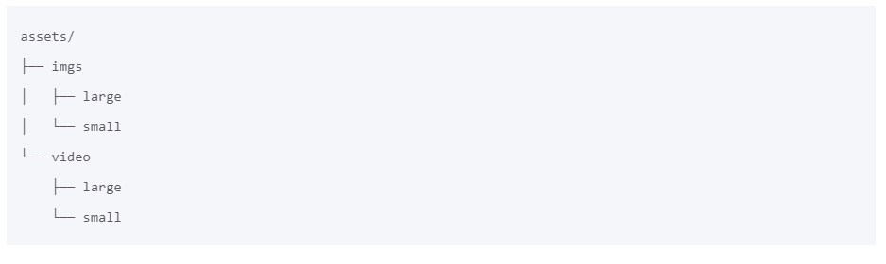

1. **Problem 3:**  
   Clear your terminal. in the lab6 directory, create the following directory structure. You need to create the pdf files as well. Remember mkdir creates directories while touch creates files. Display a tree of the directory. **Take a screenshot**:

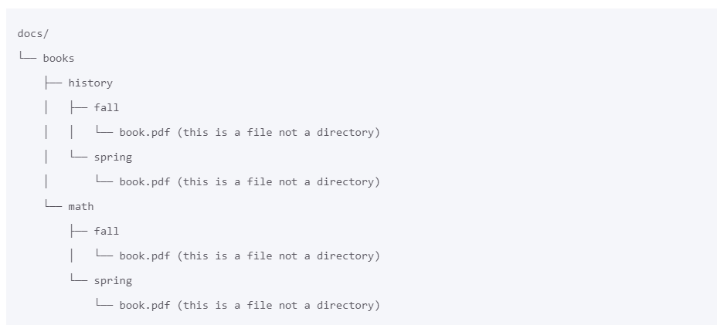

1. **Problem 4:** Brace expansion comes handy in other scenarios too. Here are some examples:
2. Create a directory in your home directory called lab6-q5. From the root of the filesystem create 3 files in the lab6-q5 directory called: program.py, people.csv, data.xls.
3. Change your current working directory to /usr/share. Create a directory in the lab6-q5 directory called movies. Create 3 files in the ~/lab6-q5/movies directory called movies.lst, marvel.txt and disney.doc.
4. Remove the files: program.py, people.csv, disney.doc, and marvel.txt.

Show your screen shot here.

## Part 16

Before working on Part 16, Run the curl command:  
curl https://cis106.com/assets/lab6cq.sh | bash

You will create a directory in your home directory called: challenge-Lab6 This directory has a bunch of files. Organize these file so that each file type has its own directory. Each file type must be moved to its respective directory. When you are done, the challenge-Lab6 directory should look like this:

challenge-lab6/

├── audio

│   ├── aac

│   │   └── all-aac-files-here

│   └── mp3

│   └── all-mp3-files-here

├── docs

│   ├── docx

│   │   └── all-docs-files-here

│   ├── pdf

│   │   └── all-pdf-files-here

│   └── xls

│   └── all-xls-files-here

└── images

├── jpg

│   └── all-jpg-files-here

└── png

└── all-png-files-here

1. Create your directory structure in a single command.
2. Work with multiple terminal windows open.

Show your screen shot here.

## Part 17

You must complete this step of the lab first. If you skip this part, you will not have the necessary files to work on this lab.

1 Install the script textFiles.sh using this command:

curl https://cis106.com/assets/installTextFiles.sh | bash && source ~/.bashrc

* 1. Read the help section of the textFiles script to learn how to use it.
  2. Download all the books, csv files and json files
  3. You should now have these directories in your machine: ~/Documents/Books, ~/Documents/Csv, ~/Documents/Json

Show your screen shot here.

## Part 18

### READ ME FIRST

*The /etc/passwd file stores user’s account information. Each account data occupies a single line in a file and when a new account is created a new entry with the new user’s information is added. The /etc/passwd records contain several fields, 7 in total. These fields are described in the image below. In this lab, we are going to use the passwd file in combination with the commands for handling text files. The goal is to demonstrate how to use these commands successfully for administering a system.*

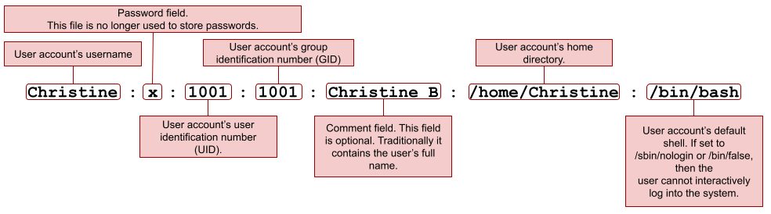

### Question 1: cat, tac, head, tail

1. Display the content of the /etc/passwd file.
2. Display the content of the /etc/passwd file in reverse order.
3. Display the content of the /etc/passwd file with line numbers and the $ to indicate the end of every line.
4. Display the first 5 lines of a the /etc/passwd file.
5. Display the last 5 lines of the /etc/passwd file.

Show your screen shot here.

### Question 2: cut

1. Display the first field of the /etc/passwd file.
2. Display the first and last field of the /etc/passwd file
3. Display the first and last field of the /etc/passwd file with the = as the output delimiter.
4. Display all the fields of the /etc/passwd file except the 3rd field.

Show your screen shot here.

### Question 3: Paste, wc

1. Download these files using curl. Use the command: curl -s URL-here -o name-of-file where the name of the file is the one given in the URL. After Downloading the files, paste the files
   * **https://cis106.com/assets/shopping.txt**
   * **https://cis106.com/assets/tasks.txt**
2. How many lines does the book dracula book have?
3. How many words does the book “Pride and Prejudice” have?
4. Sort the file /etc/passwd

Show your screen shot here.

### Question 4: tr, grep

1. Replace the ; for a , in the cereal.csv file
2. Display every line that contain the word love in the book *“Pride and Prejudice”*
3. Display every line that contains exactly the word love or hate in the book *“Pride and Prejudice”* with line numbers
4. Display every line that starts exactly with the word **“love”** in the book *Dracula*
5. Display every line that starts with an upper case letter or a number in the book *Dracula*.

Show your screen shot here.

### Question 5: awk and sed

1. Print the first and last field of the cars.csv file
2. Print the first and last field of the cars.csv file with the string " made in " as a delimiter
3. Print the cars.csv file in such a way that the output looks like this for every line:

The Chevy S-10 has 4 cylinders and is made in US

1. Print the cars.csv file excluding the first 2 records (lines).
2. Print all the car names in upper case.
3. Replace all the instances of the word Dracula for the word Alucard in the book dracula.
4. Insert a blank line after each line in the /etc/passwd file
5. Replace all the repeated blank lines for a single blank line in the book *“Pride and Prejudice”*

Show your screen shot here.

### Question 6: I/O Redirection

1. How many users can login with the /bin/bash shell?
2. How many users have the /sbin/nologin shell assigned?
3. How many ford vehicles are there in the cars.csv file
4. How many 4 letter words are there in the bible?

Show your screen shot here.

### Question 7: Challenge

1. Display only the names of the cereals in the cereal.csv file. *(Tip: use cut, awk and the pipe)*
2. Sort the output of the previous command and save it to a file called cereal-sorted.csv. *(Beware that the first 2 lines need to be removed)*
3. Display the names of the cereals and the amount of calories they have per serving.
4. Repeat the previous command but replace the ; with a ,

Show your screen shot here.

## Part 19

Include your experiences and answers to all the underlying parts in your report.

I spent hours and minutes to finish this hands-on lab.

I have completed (percent) of this lab. I expect a grade of (A, B, C, D or F) on this lab.

This lab helped me refresh users and groups, and practice file management commands using real-world examples. Choose a number to indicate how much this lab helped you.

1 2 3 4 5

(less helpful) (more helpful)

*Submit your script to the Assignment Portal

Thank you!